HW assignment (Vlasov and PIC)

1. Two Stream Instability

a) Two stream instability is a standard test case for the Vlasov-Poisson system, for which analytic results from the dispersion relation are available for code validation. In all simulations, let’s set ε = 0.001 and v ∈ [−10, 10]. Run the Vlasov-Poisson solver with the following initial conditions:



and with Lx = 2π/k, T = 50, Nx = Nv = 256. For the different stream velocities v0 given below, plot the square root of the field energy ∫|E|2dx as a function of time and compare to the analytic growth eωit, obtained from the dispersion relation:



b) Now run the 1D electrostatic PIC code with similar initial conditions to simulate the two-stream instability. Compare the simulated growth rate with the analytical solutions used in a). Describe the difference between the two simulations. (hint: for the PIC simulation, you might need to adjust the ε value for a meaningful initial perturbation).

1. Bump-on-tail instability

a) Bump-on-tail instability is another useful test case for kinetic code validation, which has nice and simple analytical solutions to compare with. First setup initial conditions in the Vlasov-Poisson code as:

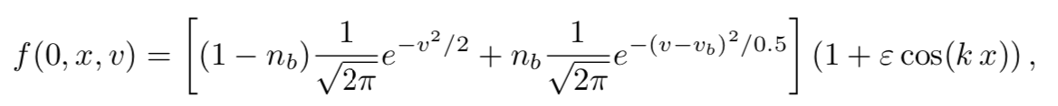

and with k = 0.3, Lx = 2π/k, T = 60, nb = 0.1, vb= 4.5. As before, compare the analytic growth rate e0.198t with the simulation results (total E field energy).

b) Now setup the bump-on-tail instability using the 1D electrostatic PIC code with similar initial conditions in the same simulation domain, compare the simulated growth rate with the analytic rate used in a). Describe the difference between the two simulations.